**Lab Report**

Title: Modernizing the Electrical Grid with Environmental Justice: Using Esri Suitability Analysis to Prioritize Grid Updates

Notice: Dr. Bryan Runck

Author: Cecelia Isaac

Date: May 7, 2021

**Project Repository:** https://github.com/CeceliaAi/GIS5572/tree/master/Final%20Project

**Abstract**

In this project, I performed a suitability analysis in ArcGIS Pro to determine the counties most in need of electrical energy infrastructure updates or installation. This project uses a variety of criteria to determine suitability, including NRI Risk Score, population demographics, and renewable energy potential. Beginning with a table of high-need counties, I used Suitability Analysis tools to calculate a suitability layer, a polygon layer of georeferenced counties symbolized by priority. The data I used was weighted by importance to the final output. The table of high-need counties was previously created by me to find counties with low infrastructure per capita. An important piece of this project was getting disparate information in one place, and in that the project was successful and the results accurate. One important factor in accurate results would have been data about most recent upgrades, which would be a significant factor in prioritizing future upgrades. While the suitability analysis was successful, the argument could easily be made to include more factors, and further discussion could be had about how the criteria were weighted.

**Problem Statement**

The problem is to prioritize counties in need of electrical infrastructure based on their demographic profile. To do this, I ran a suitability analysis, beginning with a base table of counties in need of physical infrastructure, and adding in demographics variables. The tools are simple to run. The real difficulty of using the suitability layer to appropriately weight the variables. Table 1 shows only rows for the two major steps, but each one requires iterative testing of the data, specifically the weighting of each criterion.

*Table 1. Data requirements*

|  |  |  |  |  |  |  |
| --- | --- | --- | --- | --- | --- | --- |
| **#** | **Requirement** | **Defined As** | **Spatial Data** | **Attribute Data** | **Dataset** | **Preparation** |
| 1 | Potential sites as suitability layer | Table of high-need counties | Polygons | County assets | High Need Counties | Previously prepared |
| 2 | Suitability analysis | NRI Risk Score, demographic data, and renewable energy potential | Shapefiles organized by county | Extensive | Multiple; see next table | Grouped by county, joined to shapefile |

**Input Data**

The number of variables that could be used for a suitability analysis is infinite. My cutoff was based on what data was available country-wide at a county level. First, I created a table of infrastructure needs that tracked physical county assets (High Need Counties). This dataset includes electrical power plants, substations, and transmission lines. It also factors in current energy consumption. For my suitability analysis, I used demographic data, population growth, and income data from Esri’s data browser, and renewable energy potential from USGS. The last piece of data was the NRI Risk Score for each county, which determines risk from natural hazards.

*Table 2. Input data*

|  |  |  |  |
| --- | --- | --- | --- |
| **#** | **Title** | **Purpose in Analysis** | **Link to Source** |
| 1 | High Need Counties Table | Base layer to make the suitability analysis layer | Created myself, sources are in References section |
| 2 | NRI Risk Score | Determine which counties are at risk of natural disasters | [NRI](https://hazards.geoplatform.gov/portal/apps/MapSeries/index.html?appid=ddf915a24fb24dc8863eed96bc3345f8) |
| 3 | Population Growth | Determine demand on the infrastructure in the coming years | Esri Data Browser |
| 4 | Racial Demographics | Determine historically marginalized communities | Esri Data Browser |
| 5 | Income | Determine low-income (and therefore potentially underfunded) communities | Esri Data Browser |
| 6 | Geothermal Potential | Determine renewable energy potential | [USGS](https://maps.nrel.gov/re-atlas/?aL=JlFHoz%255Bv%255D%3Dt%26kEU0Ap%255Bv%255D%3Dt%26kEU0Ap%255Bd%255D%3D1%26aN-EQ2%255Bv%255D%3Dt%26aN-EQ2%255Bd%255D%3D2%26AMzVXM%255Bv%255D%3Dt%26AMzVXM%255Bd%255D%3D3%26G7wxJd%255Bv%255D%3Dt%26G7wxJd%255Bd%255D%3D4%267qLAVM%255Bv%255D%3Dt%267qLAVM%255Bd%255D%3D5%263RSdgP%255Bv%255D%3Dt%263RSdgP%255Bd%255D%3D6%26HQIuk_%255Bv%255D%3Dt%26HQIuk_%255Bd%255D%3D7%26LfcTu0%255Bv%255D%3Dt%26LfcTu0%255Bd%255D%3D8%26BYFsT7%255Bv%255D%3Dt%26BYFsT7%255Bd%255D%3D9%26gqexyY%255Bv%255D%3Dt%26gqexyY%255Bd%255D%3D10&bL=clight&cE=0&lR=0&mC=38.71980474264237%2C-102.65625&zL=4) |
| 7 | Solar Potential | Determine renewable energy potential | [USGS](https://maps.nrel.gov/re-atlas/?aL=JlFHoz%255Bv%255D%3Dt%26kEU0Ap%255Bv%255D%3Dt%26kEU0Ap%255Bd%255D%3D1%26aN-EQ2%255Bv%255D%3Dt%26aN-EQ2%255Bd%255D%3D2%26AMzVXM%255Bv%255D%3Dt%26AMzVXM%255Bd%255D%3D3%26G7wxJd%255Bv%255D%3Dt%26G7wxJd%255Bd%255D%3D4%267qLAVM%255Bv%255D%3Dt%267qLAVM%255Bd%255D%3D5%263RSdgP%255Bv%255D%3Dt%263RSdgP%255Bd%255D%3D6%26HQIuk_%255Bv%255D%3Dt%26HQIuk_%255Bd%255D%3D7%26LfcTu0%255Bv%255D%3Dt%26LfcTu0%255Bd%255D%3D8%26BYFsT7%255Bv%255D%3Dt%26BYFsT7%255Bd%255D%3D9%26gqexyY%255Bv%255D%3Dt%26gqexyY%255Bd%255D%3D10&bL=clight&cE=0&lR=0&mC=38.71980474264237%2C-102.65625&zL=4) |
| 8 | Wind Generation Potential | Determine renewable energy potential | [USGS](https://maps.nrel.gov/re-atlas/?aL=JlFHoz%255Bv%255D%3Dt%26kEU0Ap%255Bv%255D%3Dt%26kEU0Ap%255Bd%255D%3D1%26aN-EQ2%255Bv%255D%3Dt%26aN-EQ2%255Bd%255D%3D2%26AMzVXM%255Bv%255D%3Dt%26AMzVXM%255Bd%255D%3D3%26G7wxJd%255Bv%255D%3Dt%26G7wxJd%255Bd%255D%3D4%267qLAVM%255Bv%255D%3Dt%267qLAVM%255Bd%255D%3D5%263RSdgP%255Bv%255D%3Dt%263RSdgP%255Bd%255D%3D6%26HQIuk_%255Bv%255D%3Dt%26HQIuk_%255Bd%255D%3D7%26LfcTu0%255Bv%255D%3Dt%26LfcTu0%255Bd%255D%3D8%26BYFsT7%255Bv%255D%3Dt%26BYFsT7%255Bd%255D%3D9%26gqexyY%255Bv%255D%3Dt%26gqexyY%255Bd%255D%3D10&bL=clight&cE=0&lR=0&mC=38.71980474264237%2C-102.65625&zL=4) |
| 9 | County Shapefile | Base layer shapefile to join tabular data | [NHGIS IPUHMS](https://data2.nhgis.org/) |

**Methods**

In the first part of the project, I prepared data in order to run a layer through the Make Suitability Layer tool (Figure 1). This involved taking all of my line, polygon, or tabular data and joining it to the High Need Counties table. The reason this is necessary is because later, in the Set Criteria Properties step, only point data, variable (Esri) data, and field data can be weighted. Joining the tables beforehand ensured I could easily use the field data later on. This step is not necessary when writing in Python, because the Set Criteria Properties function allows for more data types.

*Figure 1. Process flow diagram part I*

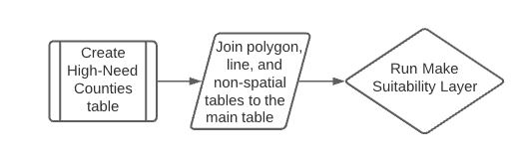

In the second part of the project, I added in my point data and weighted it using the Add Point Based Suitability Criteria tool. I also added Esri’s data through the Add Variable Based Suitability Criteria tool. I used Set Criteria Properties to weight these data. Then I set the weights of the fields (from columns joined in the previous part) using Add Field Based Suitability Criteria. I weighted this as well. In addition to setting percentages of ranked weighted, there are also three ways to weight data: positive, inverse, and ideal. I used positive for all except one, Income. I used Inverse on Income to prioritize low-income counties. Then I ran Calculate Suitability Score to find my results. During my first pass at this process, I went back several times to tweak my weights until I was satisfied with the output results. When I re-did my project using ArcPy, I determined my weights beforehand so less adjusting was needed.

*Figure 2. Process flow diagram part II*

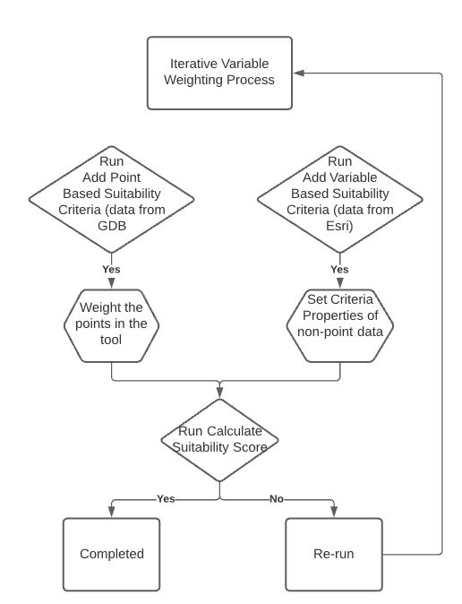

**Results**

Figure 3 shows my results in the form of a choropleth map where the darker color indicates a high need. The symbology is based on the Final Score field calculated by the Suitability Analysis tool. These results address the problem statement of identifying counties that should be prioritized for upgrades based on the needs of the county.

*Figure 2. Results*

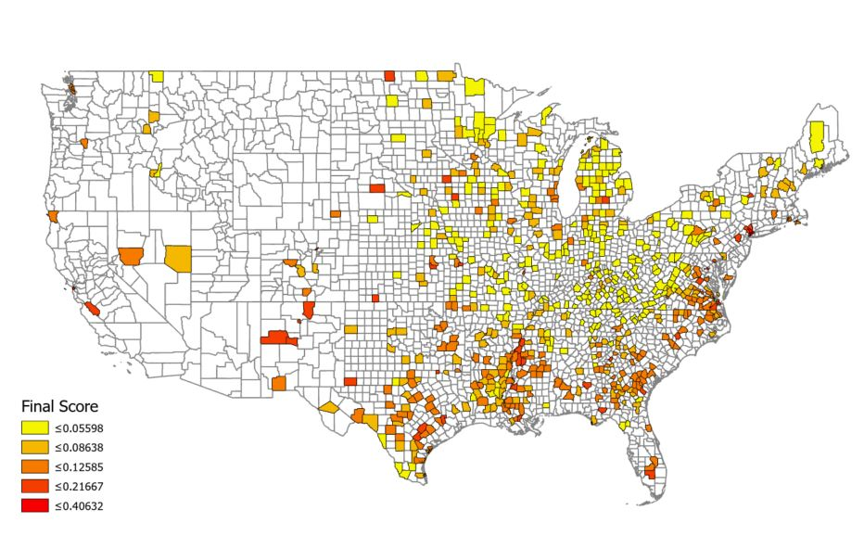

**Results Verification**

The variables used in the suitability analysis would depend on the user, so my output is likely not useful in every scenario. I also felt deciding the weights of each variable was a soft process. I would prefer to have those weight ranges pre-decided by further research, rather than my method of trying, rinsing, and repeating in the tool. However, my results are accurate to my process and chosen variables. When I repeated my process using ArcPy, I decided my weights and rankings beforehand, but still felt the process to be subjective.

**Discussion and Conclusion**

I learned how to run a Suitability Analysis. I learned that while I might not have all the data I would have wanted, this tool is extremely useful in starting the conversation, and in flexibility. Variables can be added later. I also learned the hardest part was the weighting the data. I felt I needed more research to decide how I wanted to weight my criteria. I did not anticipate this being a difficult aspect.

Data collection was also difficult, since there is not a central database of country-wide data. I did not have data of most recent upgrades, which would be a significant factor in prioritizing future upgrades. That said, the purpose of this project is environmental justice, which means keeping an emphasis on marginalized communities and their needs. Even if an area has had recent upgrades, does not mean they could not benefit from more attention, especially if the community is historically neglected.

I had a more systematic approach to weighting my variables the second time I performed my analysis. However, even the resources I read on multi-criteria evaluation recommended having a panel of experts determine weight. I desperately looked for another expert in the room, but since my cat doesn’t know GIS, I had to be the one to make the decisions based on how I felt about each variable.

**References**

Brad Plumer, Hiroko Tabuchi. (2021, February 17). The Far-Reaching Effects of the Storm, on Power and People. *New York Times*. <https://www.nytimes.com/2021/02/17/climate/storms-power-outage-newsletter.html>

*City and County Energy Profiles—OpenEI DOE Open Data*. (n.d.). Retrieved April 22, 2021, from <https://openei.org/doe-opendata/dataset/city-county-energy-profiles>

*Electric Retail Service Territories | HIFLD Open Data*. (n.d.). Retrieved April 7, 2021, from <https://hifld-geoplatform.opendata.arcgis.com/datasets/c4fd0b01c2544a2f83440dab292f0980_0?geometry=134.976%2C19.251%2C19.136%2C62.725>

Erin Douglas, Kate McGee, Jolie McCullough. (2021, February 17). Texas leaders failed to heed warnings that left the state’s power grid vulnerable to winter extremes, experts say. *The Texas Tribune*. <https://www.texastribune.org/2021/02/17/texas-power-grid-failures/>

*Generating Units*. (n.d.). Retrieved April 22, 2021, from <https://hifld-geoplatform.opendata.arcgis.com/datasets/14b5a08efaec446ba7aa0121220141fa_0>

Gretchen Bakke. (n.d.). *The Grid: The Fraying Wires Between Americans and Our Energy Future*. Bloomsbury.

HIFLD Open GP - Energy. (2020a). *Electric Substations* [Shapefile]. Homeland Infrastructure Foundation-Level Data (HIFLD). <https://hifld-geoplatform.opendata.arcgis.com/datasets/electric-substations?geometry=-110.440%2C43.508%2C-79.920%2C48.828>

HIFLD Open GP - Energy. (2020b). *Control Areas* [Shapefile]. Homeland Infrastructure Foundation-Level Data (HIFLD). <https://hifld-geoplatform.opendata.arcgis.com/datasets/control-areas>

HIFLD Open GP - Energy. (2020c). *Electric Power Transmission Lines* [Shapefile]. Homeland Infrastructure Foundation-Level Data (HIFLD). <https://hifld-geoplatform.opendata.arcgis.com/datasets/electric-power-transmission-lines/data?geometry=-102.431%2C44.299%2C-86.819%2C46.986>

*How Generate Network Spatial Weights works—ArcGIS Pro | Documentation*. (n.d.). Retrieved April 8, 2021, from <https://pro.arcgis.com/en/pro-app/latest/tool-reference/spatial-statistics/learnmoreupdatedgeneratenetworkswm.htm>

King, L. (2021, January 28). *How America’s Power Grid Is Vulnerable To Undetected Cyberattack*. <https://www.forbes.com/sites/llewellynking/2021/01/28/how-the-supply-chain-in-heavy-bulk-power-equipment-is-vulnerable-to-undetected-cyberattack/?sh=ae9ae027213a>

*Make Suitability Analysis Layer (Business Analyst)—ArcGIS Pro | Documentation*. (n.d.). Retrieved April 15, 2021, from <https://pro.arcgis.com/en/pro-app/latest/tool-reference/business-analyst/make-suitability-analysis-layer.htm>

Matthew Weiss. (2019). An assessment of threats to the American power grid. *Energy, Sustainability and Society*, *9*(18). <https://energsustainsoc.biomedcentral.com/articles/10.1186/s13705-019-0199-y>

McGanity, C. A. (2019, December 16). *Looking at what Questions a Civilian can Ask of Sensitive Government Data*. Medium. <https://medium.com/@cam1147/looking-at-what-questions-a-civilian-can-ask-of-sensitive-government-data-43f613a5315e>

Mike M. McMahon. (2017, November). *Mapping the Vulnerability and Strength of the Power Grid*. <https://isen.northwestern.edu/mapping-the-vulnerability-and-strength-of-the-power-grid>

*Multiple Hazard Index for United States Counties*. (n.d.). Retrieved April 7, 2021, from <https://hub.arcgis.com/datasets/800f684ebadf423bae4c669cb0a1d7da>

Amanda Briney. (2014, April 10). Overview of Weighted Site Selection and Suitability Analysis. *GIS Lounge*. <https://www.gislounge.com/overview-weighted-site-selection-suitability-analysis/>

*Population Growth Rate in the United States*. (n.d.). Retrieved April 22, 2021, from <https://hub.arcgis.com/datasets/a6fc3f3610d0485295cb35306a567f38>

*RE Atlas*. (n.d.). Retrieved April 24, 2021, from <https://maps.nrel.gov/re-atlas/?aL=JlFHoz%255Bv%255D%3Dt%26kEU0Ap%255Bv%255D%3Dt%26kEU0Ap%255Bd%255D%3D1%26aN-EQ2%255Bv%255D%3Dt%26aN-EQ2%255Bd%255D%3D2%26AMzVXM%255Bv%255D%3Dt%26AMzVXM%255Bd%255D%3D3%26G7wxJd%255Bv%255D%3Dt%26G7wxJd%255Bd%255D%3D4%267qLAVM%255Bv%255D%3Dt%267qLAVM%255Bd%255D%3D5%263RSdgP%255Bv%255D%3Dt%263RSdgP%255Bd%255D%3D6%26HQIuk_%255Bv%255D%3Dt%26HQIuk_%255Bd%255D%3D7%26LfcTu0%255Bv%255D%3Dt%26LfcTu0%255Bd%255D%3D8%26BYFsT7%255Bv%255D%3Dt%26BYFsT7%255Bd%255D%3D9%26gqexyY%255Bv%255D%3Dt%26gqexyY%255Bd%255D%3D10&bL=clight&cE=0&lR=0&mC=38.71980474264237%2C-102.65625&zL=4>

*Recovery Act: Smart Grid Investment Grant (SGIG) Program*. (n.d.). Energy.Gov. Retrieved April 15, 2021, from <https://www.energy.gov/oe/information-center/recovery-act-smart-grid-investment-grant-sgig-program>

*Renewable Energy Supply Curves*. (n.d.). Retrieved April 25, 2021, from <https://www.nrel.gov/gis/renewable-energy-supply-curves.html>

Sovacool, B. K., Heffron, R. J., McCauley, D., & Goldthau, A. (2016). Energy decisions reframed as justice and ethical concerns. *Nature Energy*, *1*(5), 1–6. <https://doi.org/10.1038/nenergy.2016.24>

*Suitability Analysis—ArcGIS Pro | Documentation*. (n.d.). Retrieved April 8, 2021, from <https://pro.arcgis.com/en/pro-app/latest/help/analysis/business-analyst/understanding-suitability-analysis.htm>

*The National Risk Index*. (n.d.). Retrieved April 8, 2021, from <https://hazards.geoplatform.gov/portal/apps/MapSeries/index.html?appid=ddf915a24fb24dc8863eed96bc3345f8>

*Tutorial: Rank sites with Suitability Analysis—ArcGIS Pro | Documentation*. (n.d.). Retrieved April 8, 2021, from <https://pro.arcgis.com/en/pro-app/latest/help/analysis/business-analyst/suitability-analysis-walkthrough.htm>

**Self-score**

|  |  |  |  |
| --- | --- | --- | --- |
| **Category** | **Description** | **Points Possible** | **Score** |
| **Structural Elements** | All elements of a lab report are included **(2 points each)**:  Title, Notice: Dr. Bryan Runck, Author, Project Repository, Date, Abstract, Problem Statement, Input Data w/ tables, Methods w/ Data, Flow Diagrams, Results, Results Verification, Discussion and Conclusion, References in common format, Self-score | 28 | **28** |
| **Clarity of Content** | Each element above is executed at a professional level so that someone can understand the goal, data, methods, results, and their validity and implications in a 5 minute reading at a cursory-level, and in a 30 minute meeting at a deep level **(12 points)**. There is a clear connection from data to results to discussion and conclusion **(12 points)**. | 24 | **24** |
| **Reproducibility** | Results are completely reproducible by someone with basic GIS training. There is no ambiguity in data flow or rationale for data operations. Every step is documented and justified. | 28 | **28** |
| **Verification** | Results are correct in that they have been verified in comparison to some standard. The standard is clearly stated **(10 points)**, the method of comparison is clearly stated **(5 points)**, and the result of verification is clearly stated **(5 points)**. | 20 | **20** |
|  |  | 100 | **100** |